Sidel Trade Compliance Application – Help File (Sidel)

- Logging into the website
  - Go to the following URL in your web browser:
    - http://207.195.233.151/
    - Enter your User Name & Password in the upper-right area
    - Click on the “Login” button
  - 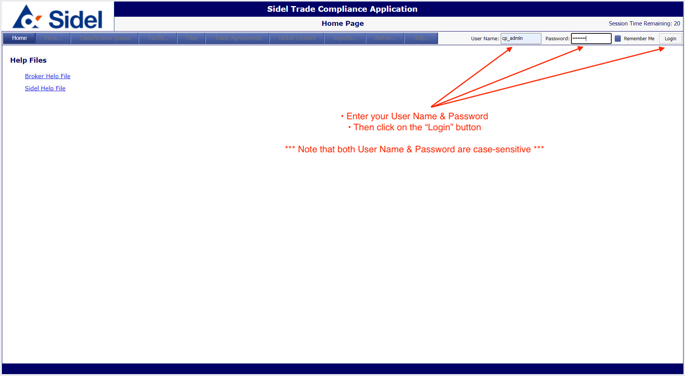
  - 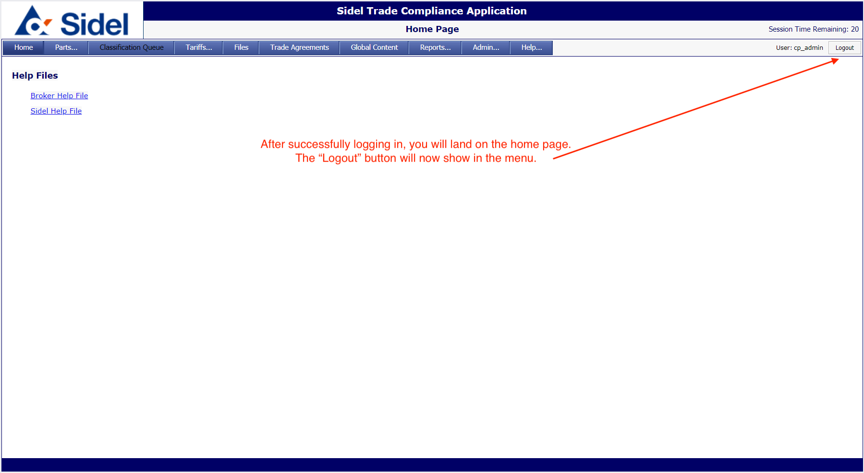
- Accessing the Parts/Products Area
  - Click on the Parts menu and then select “Part List”
  - This will take you to the parts search page
  - 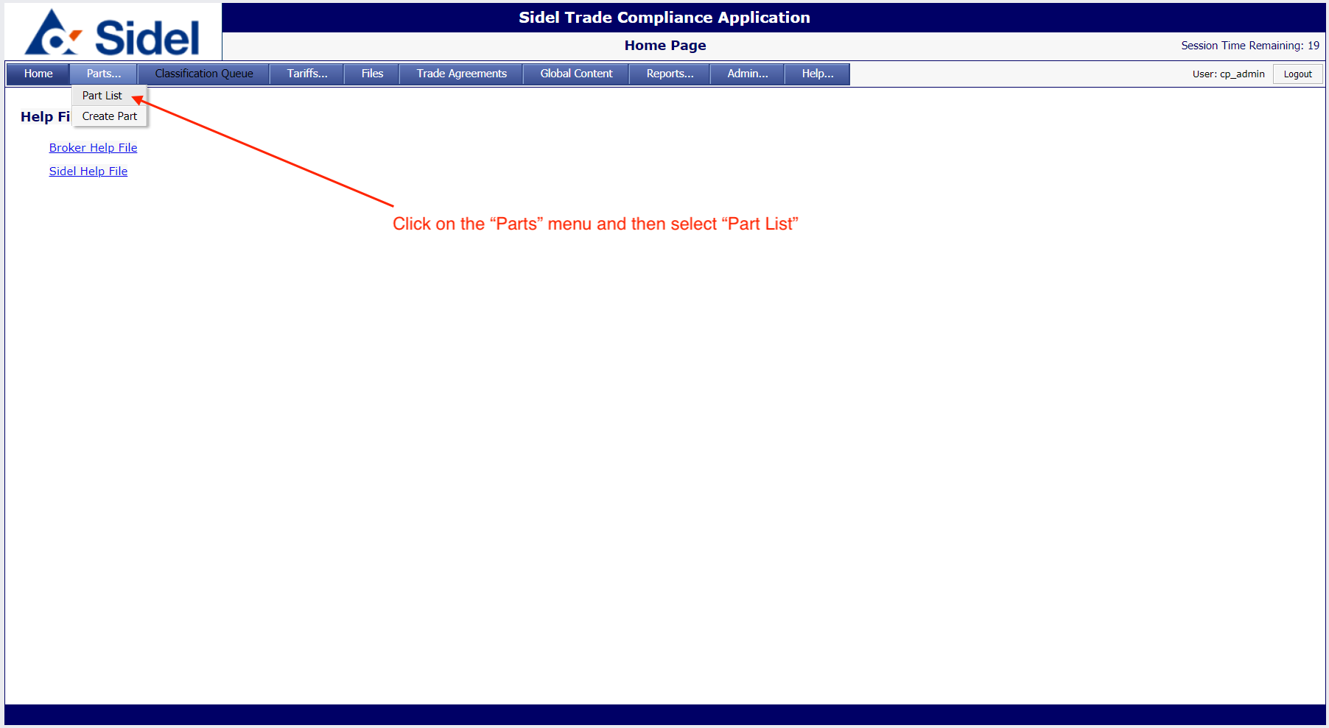
- Searching for parts in the Sidel catalog
  - The Parts List page allows you to search for parts using one or more search parameters
  - 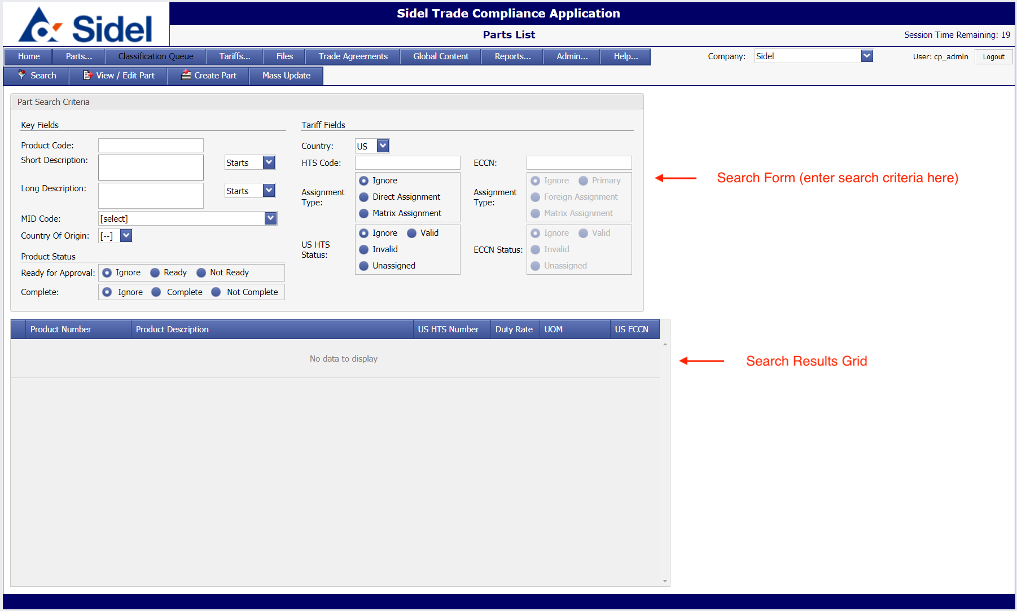
  - Clicking the “Search” button without entering any search parameters will return the entire Sidel parts database
  - 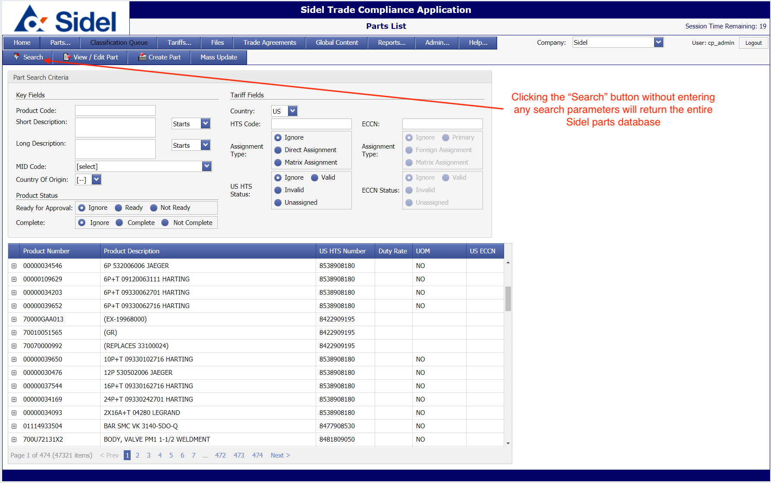
  - To search for a single part, enter the part number and click on the “Search” button.
    - You can enter a partial part number and the application will find all parts starting with the partial number entered.
    - The search results will be shown in the table below.
  - 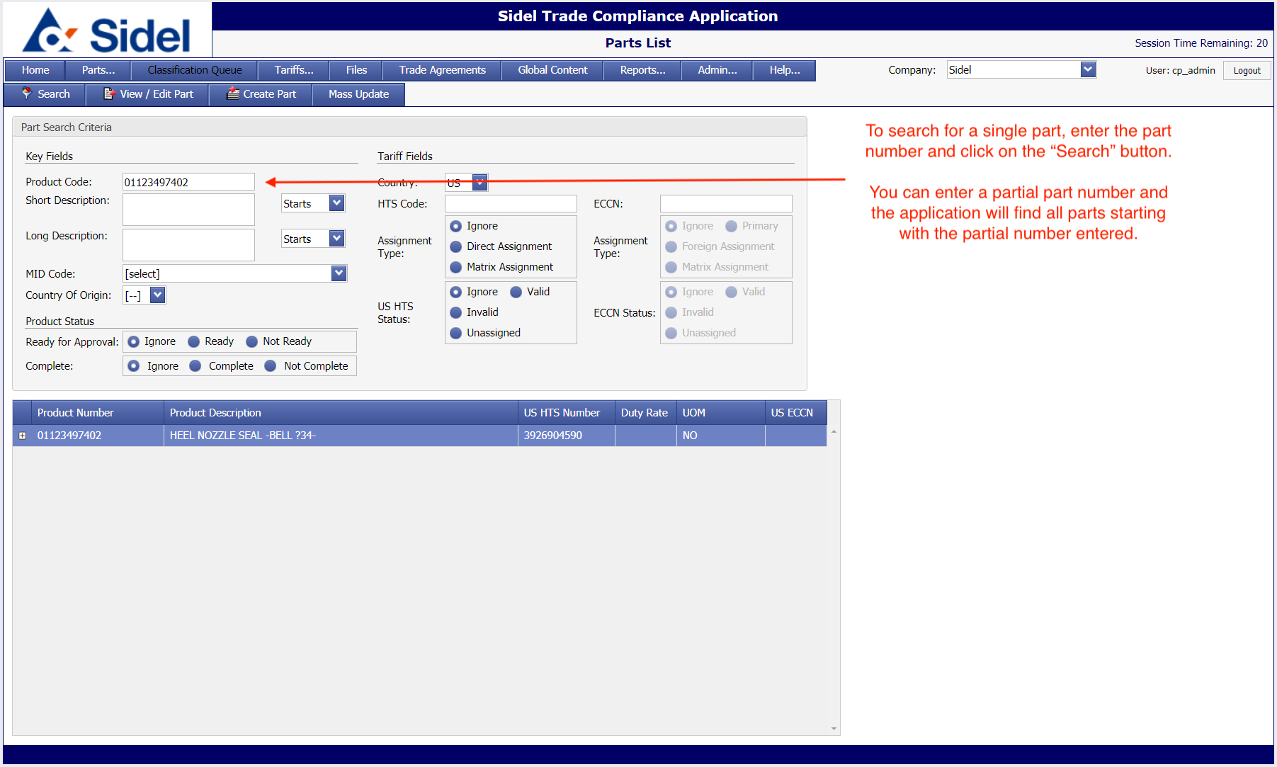
  - To search for parts by keyword, enter the keyword(s) and click the “Search” button.
    - Use the drop-down menu to select how to search:
      - Starts: Will return all parts with a description starting with the keyword(s) entered.
      - Contains: Will return all parts that have a description that contains the keyword(s) entered.
      - Ends: Will return all parts where the description ends with the keyword(s) entered.
  - 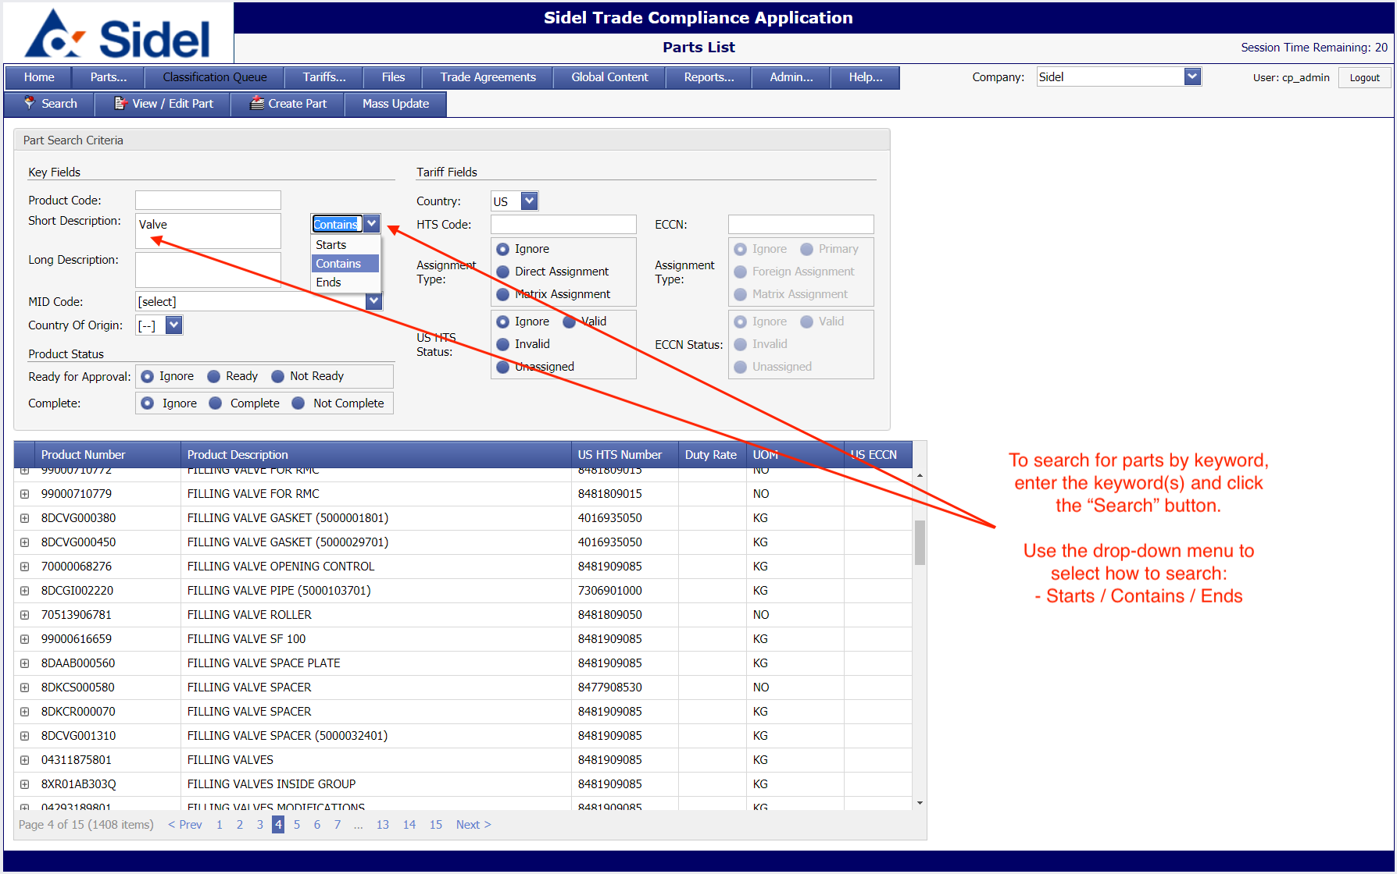
  - To search for parts by US HTS code, enter the HTS code and click the “Search” button.
    - Enter a partial HTS code to find parts at the 6-digit or 8-digit level.
  - 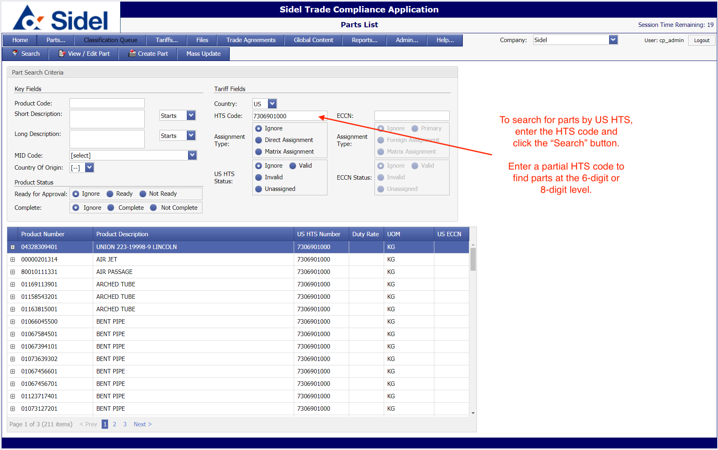
  - To search for parts based on the HTS Status, choose a status and then click the “Search” button.
    - Invalid: Choose this option to find parts that have an HTS code that is no longer valid.
    - 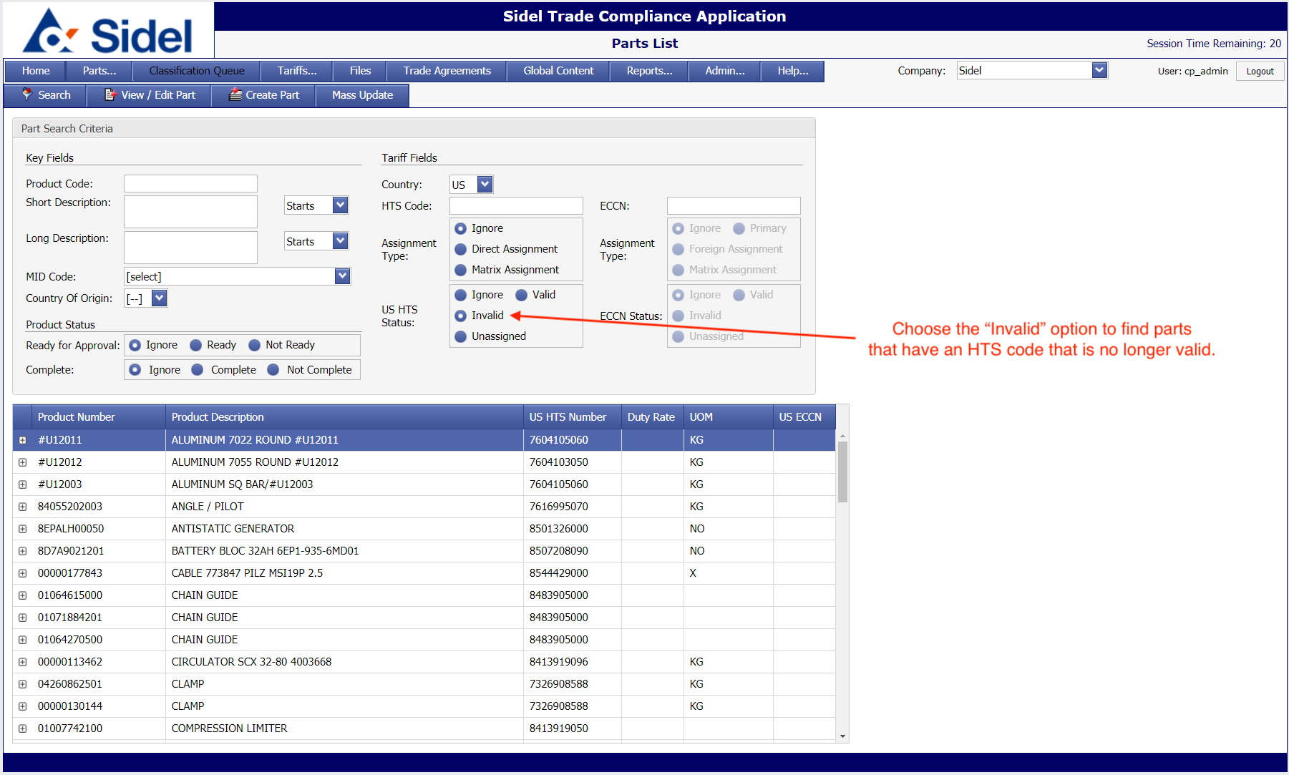
    - Unassigned: Choose this option to find parts that do not yet have an HTS code assignment.
    - 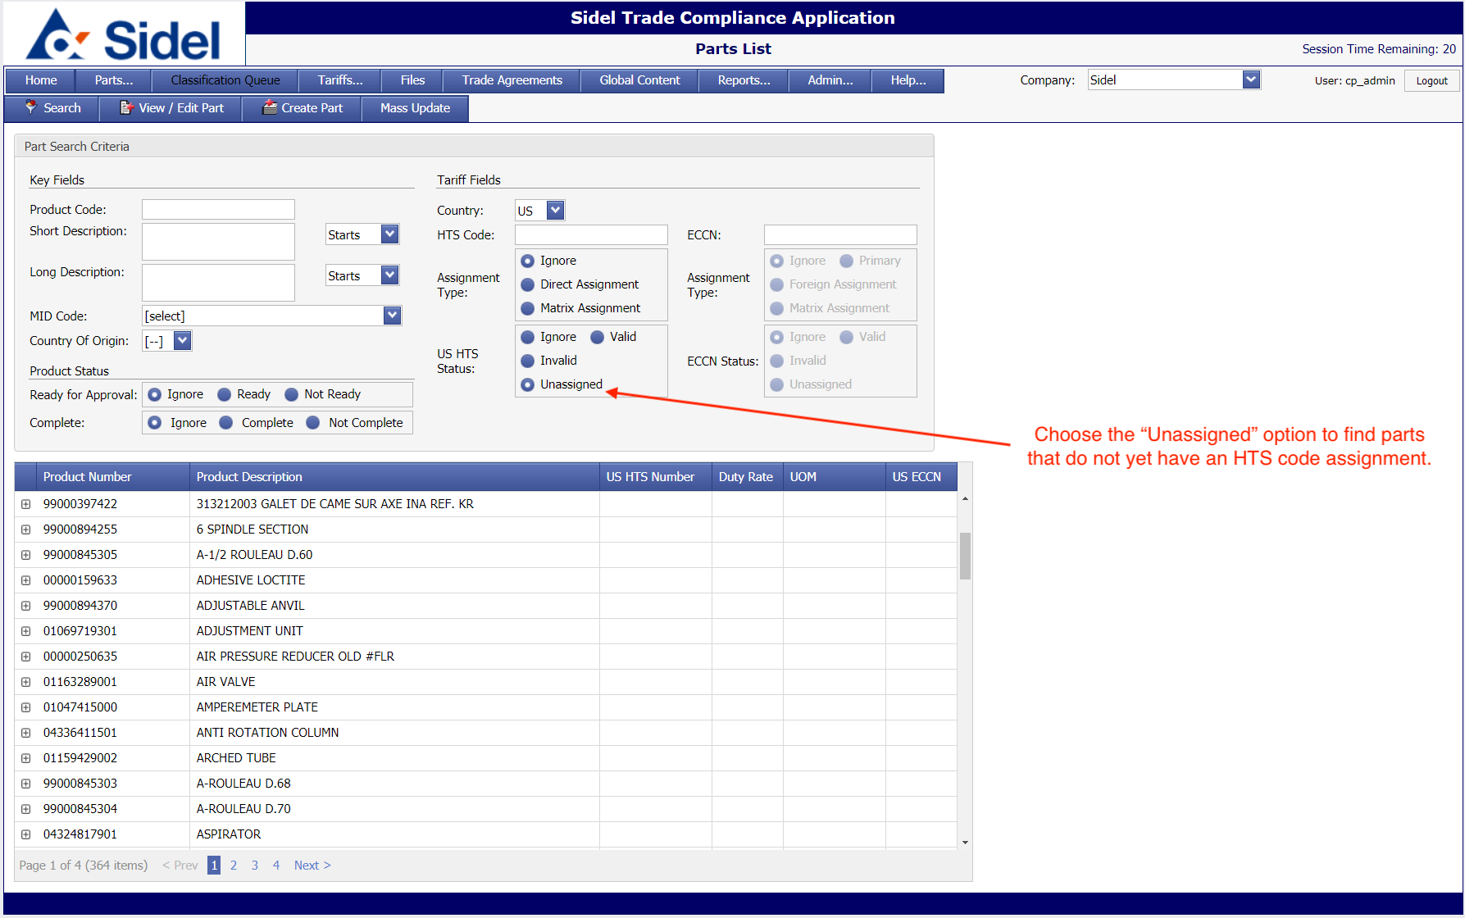
- Modifying/Updating Parts
  - To modify/update a part, select an item in the search results grid and then click on the “View/Edit Part” button in the page menu.
    - You may also double-click on an item in the search results grid to go the modify/edit screen.
  - The following items will be the key fields managed by Sidel in the part edit screen:
    - Product Number: the Sidel part/product code
    - Active: this checkbox allows Sidel to make old parts inactive
    - Short Description: a short description of the product
    - Long Description: a detailed description of the product; this is the default description shown on the parts search page/results
    - US HTS Code: the 10-digit US HTS code
    - Comments: notes/comments about any material change made to a product
    - Support Files: upload any supporting documentation related to products
  - 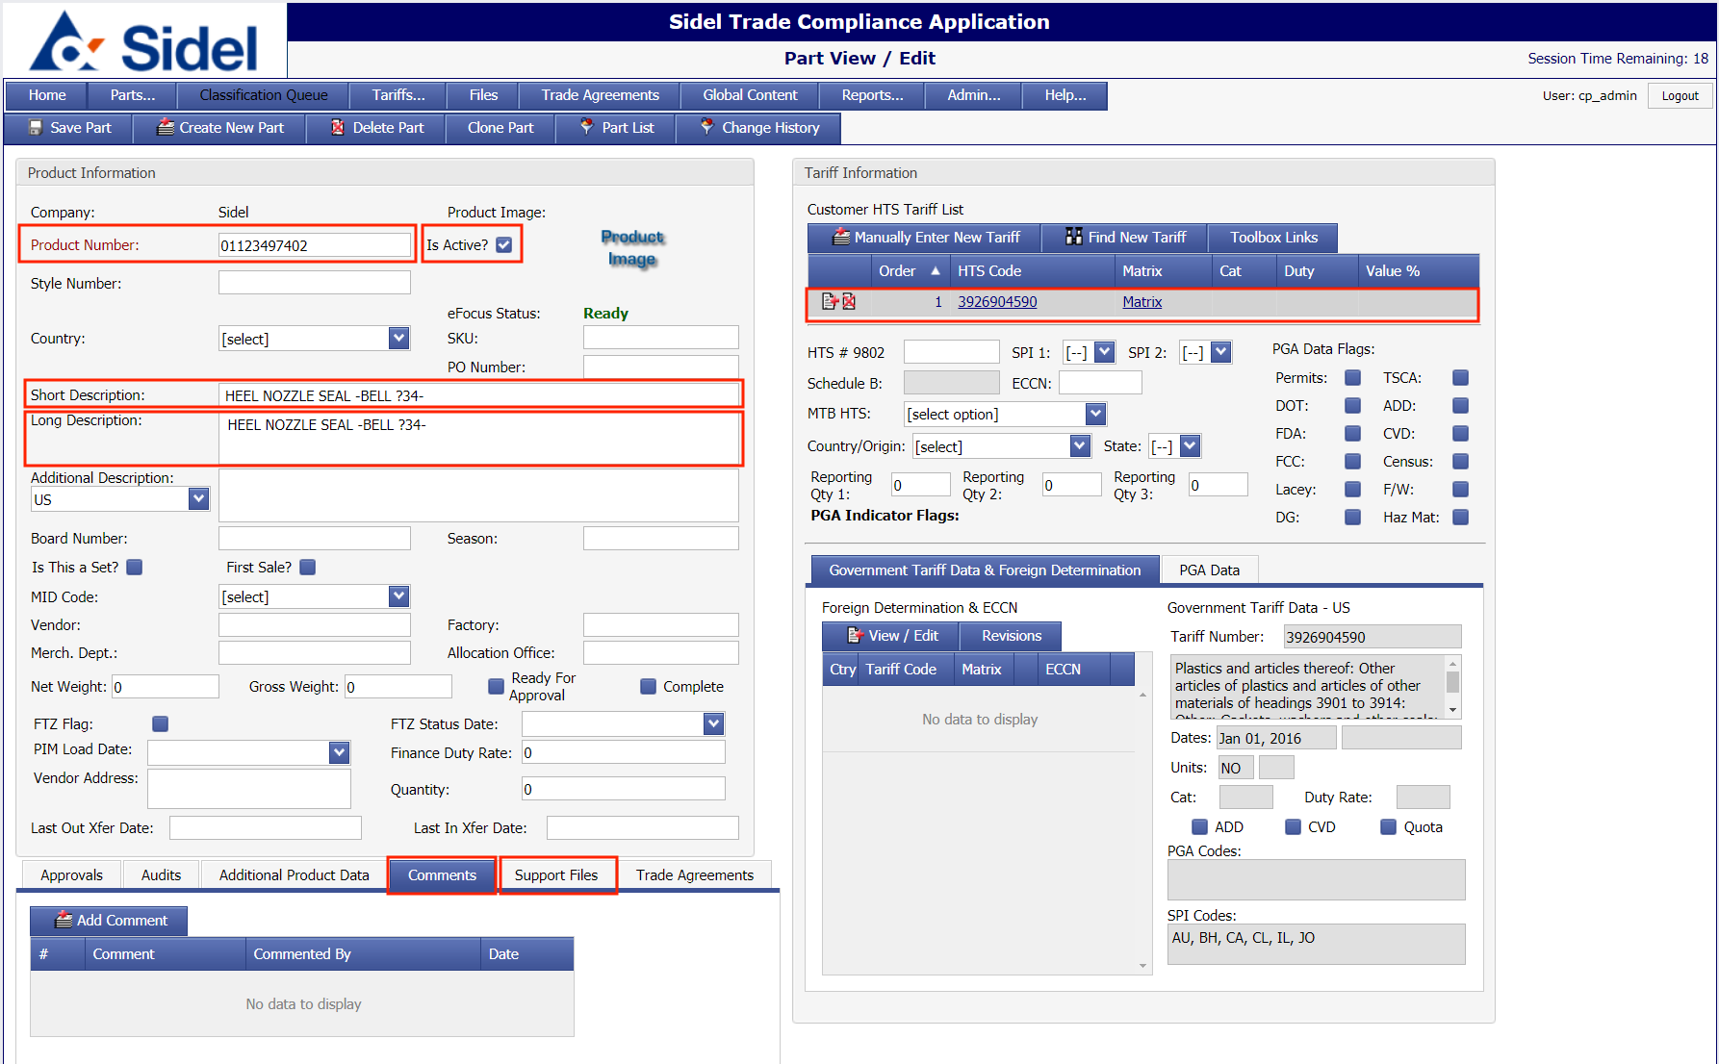
  - To add a new comment to the part, click the “Add Comment” button.
    - Enter your notes/comments for the part and then click on the “update” icon.
  - 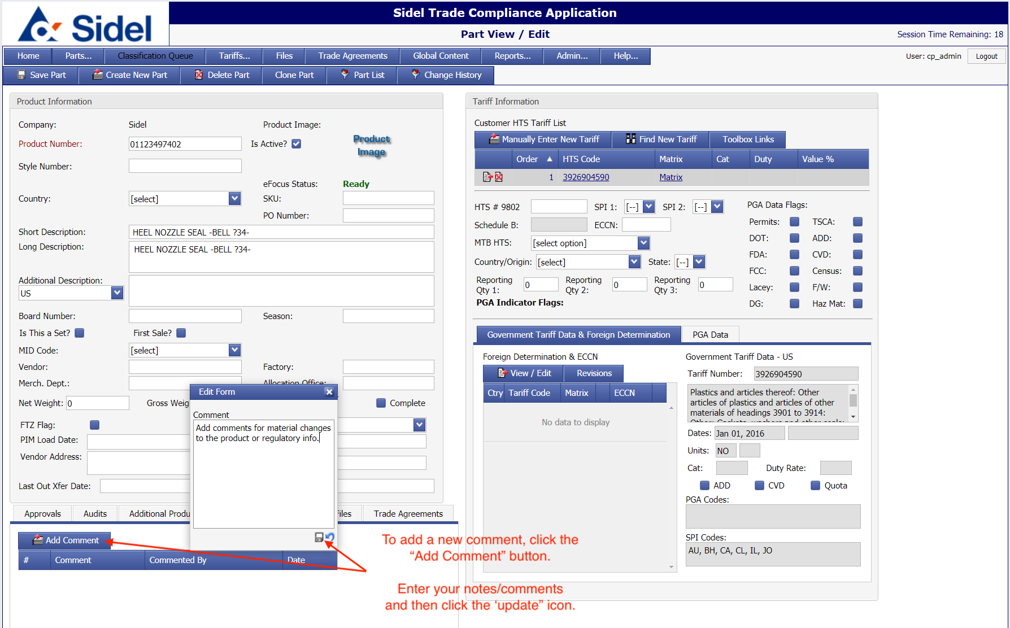
  - Assigning the US HTS Code:
    - If you know the HTS code for the part and want to enter it manually, click on the “Manually Enter New Tariff” button. Enter the 10-digit HTS code and click on the “update” icon.
    - 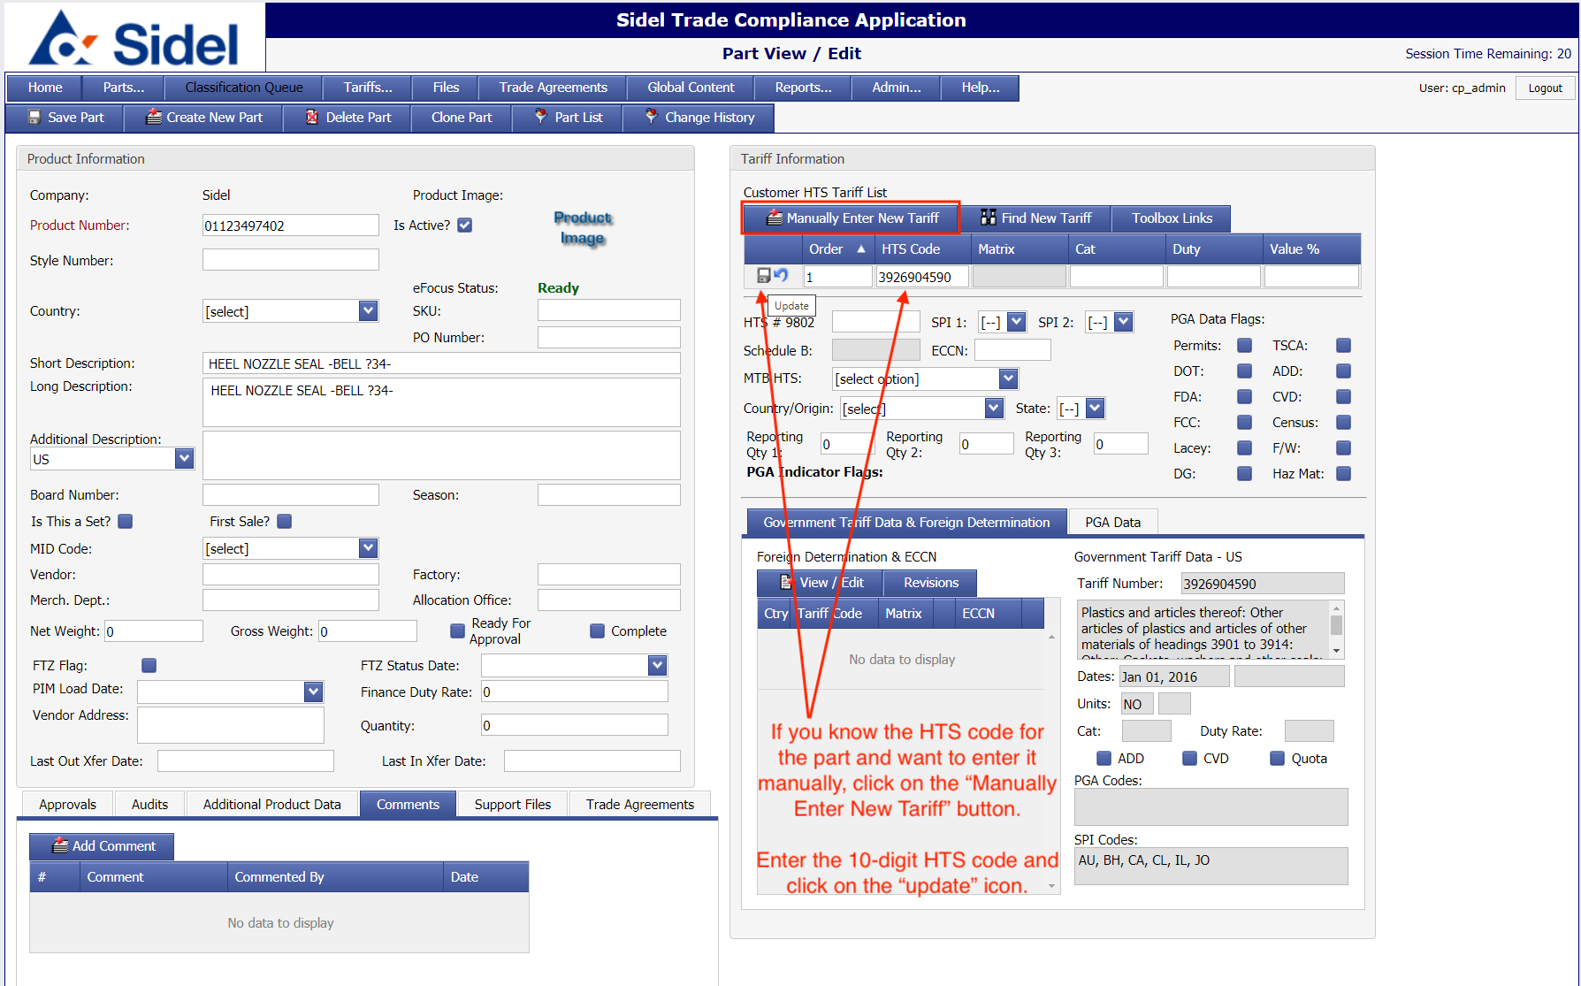
    - If you are unsure which HTS code to use, you can search for correct code using the “Find New Tariff” function.
      - Click on the “Find New Tariff” button.
      - In the pop-up window, enter a partial (6-digit or 8-digit) code in the HTS Code search field and click the “Search” button.
      - The results will be shown, including descriptions of the sections and complete (10-digit) codes.
      - Select the 10-digit HTS code you wish to assign & click on the “Add New Tariff” button.
      - The pop-up window will close & the selected HTS code will be assigned to the product.
    - 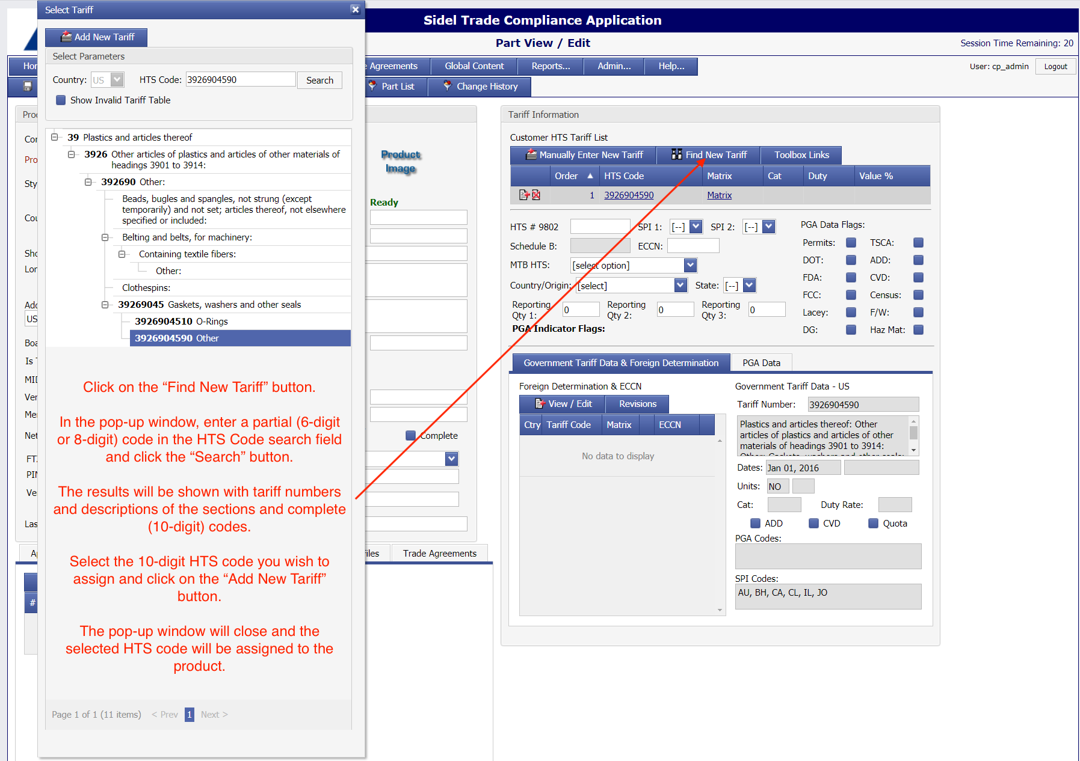
  - Viewing Special Tariff Programs/Exceptions
    - If a special tariff program/exception is associated with the assigned 10-digit HTS code, an indicator (with tariff number) will show below the assigned HTS code.
      - When you move your mouse/pointer over the indicator/tariff code, the program/exception description will be shown.
    - 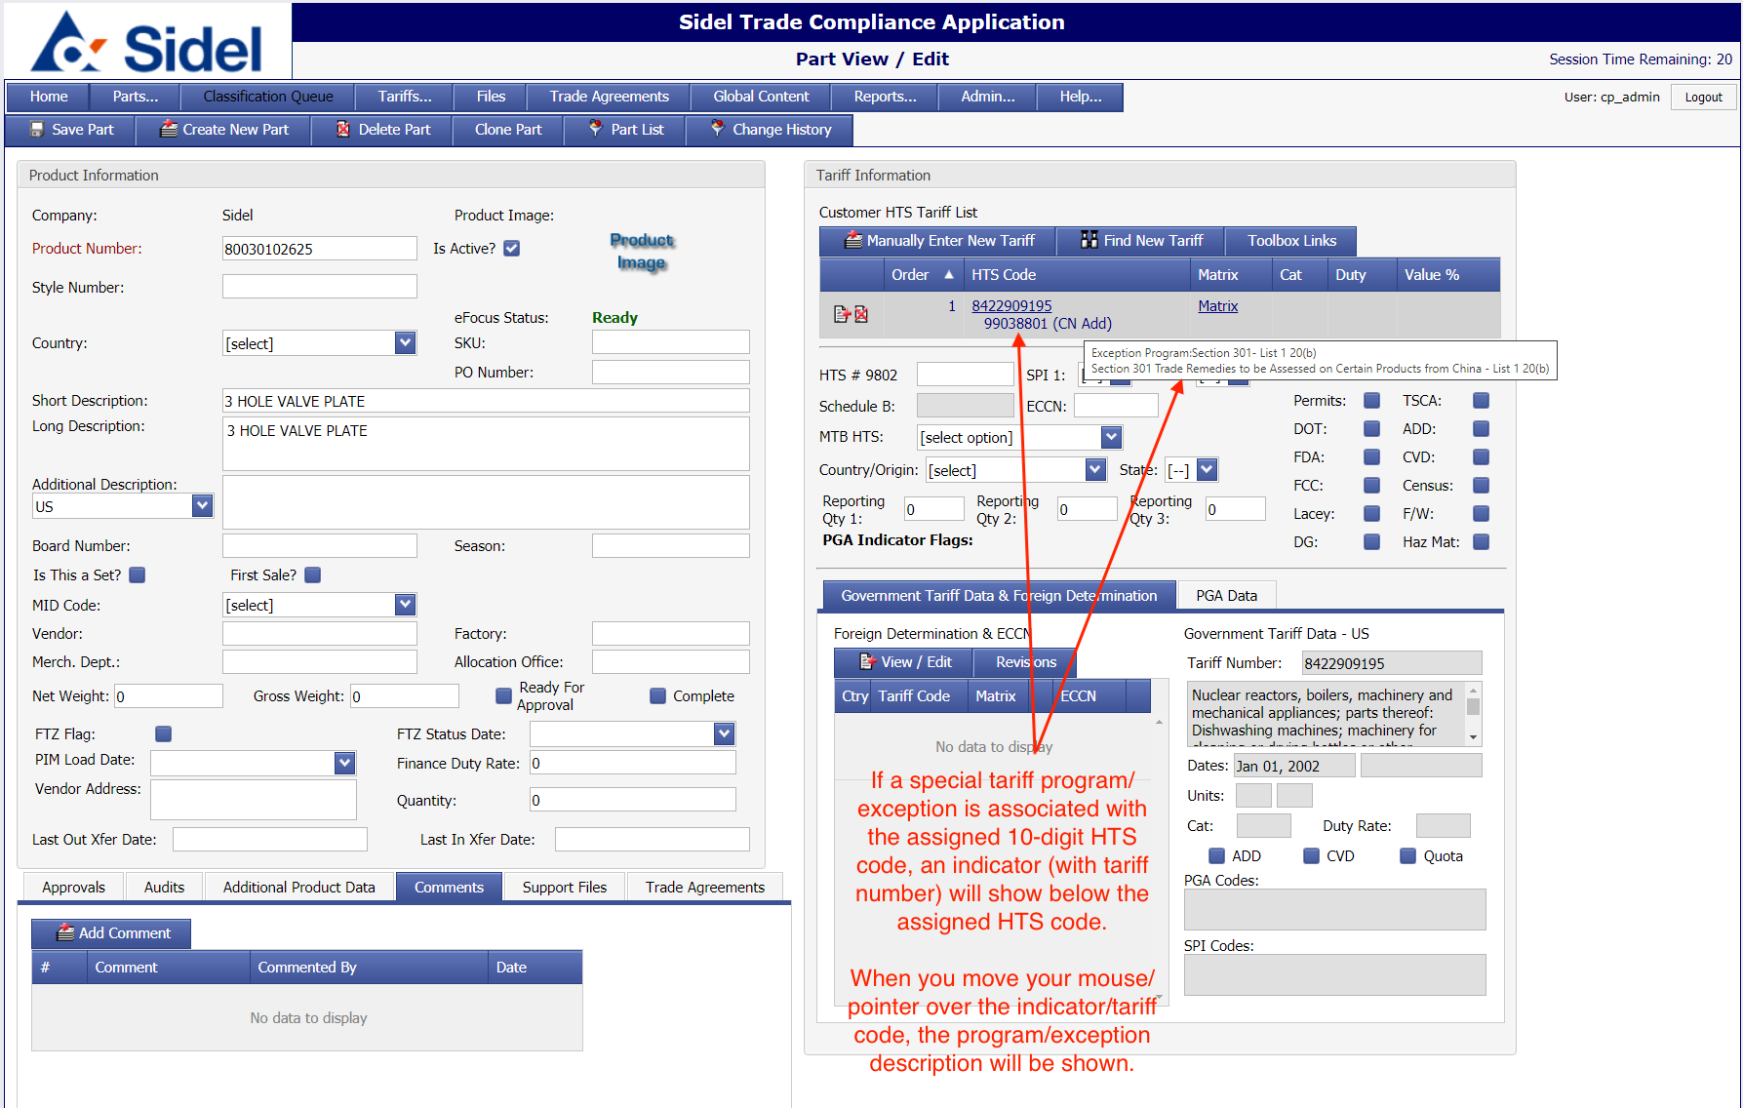
- Creating New Parts
  - You can create new parts in two ways:
    - Create a new part manually, entering all of the information into a blank part form
      - Click on the “Parts” menu and then select the “Create Part” menu item.
    - 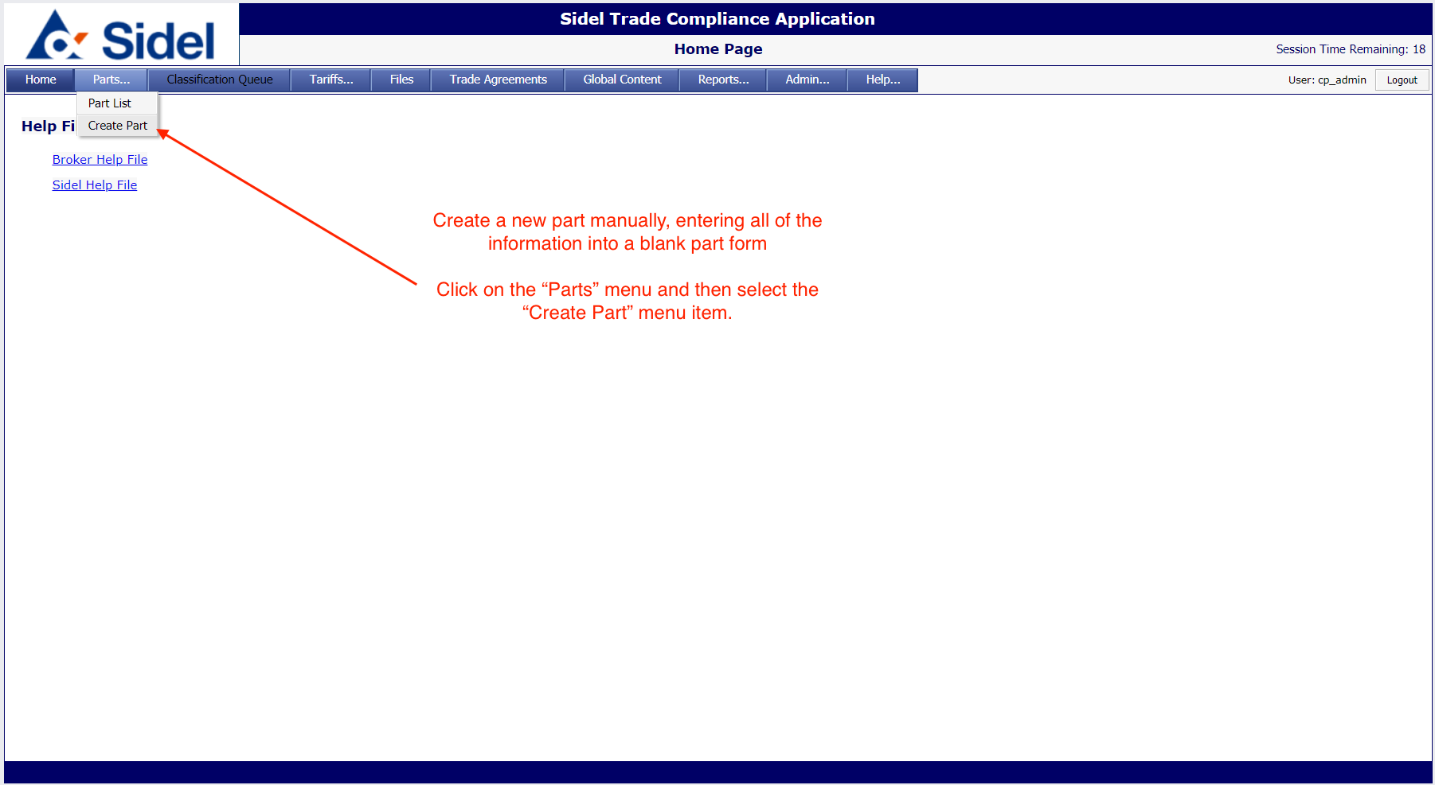
    - Clone an existing part
      - Go to the part detail/edit screen of the part you want to clone.
      - Click on the “Clone Part” page menu button.
      - Enter the new part number and click the “Save” button.
        - The application will then create a new part using the entered part number and the data from the cloned part.
    - 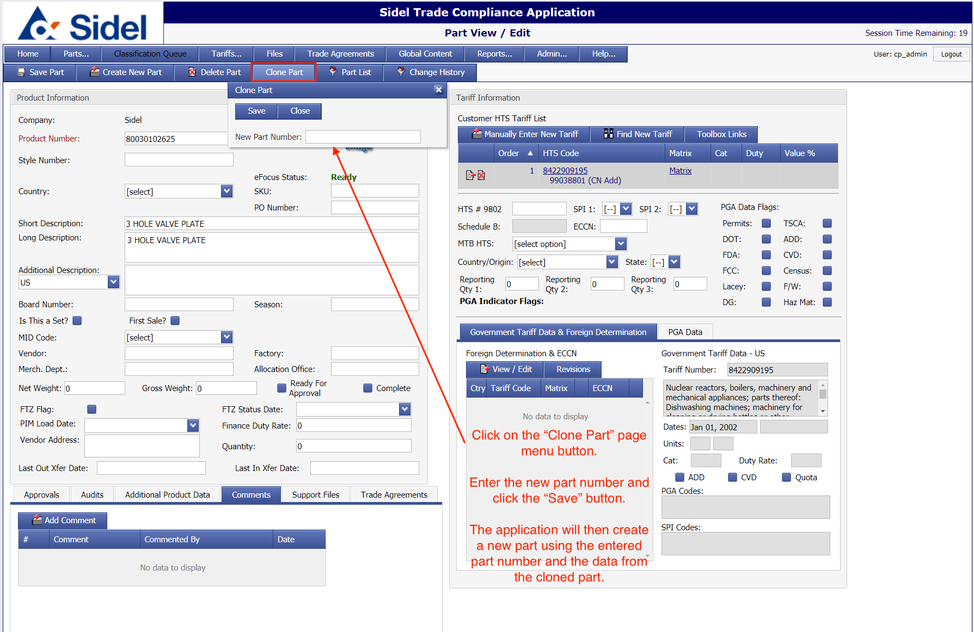
- Search US HTS Data
  - The “Tariff Search” allows users to search for complete or partial US HTS codes.
  - Results are shown in a “tree” view, allowing the user to see codes and descriptions, from chapter level through the complete 10-digit level.
  - Selecting a 10-digit code will show the following:
    - Complete 10-digit description
    - Effective dates
    - Rates and special programs
  - 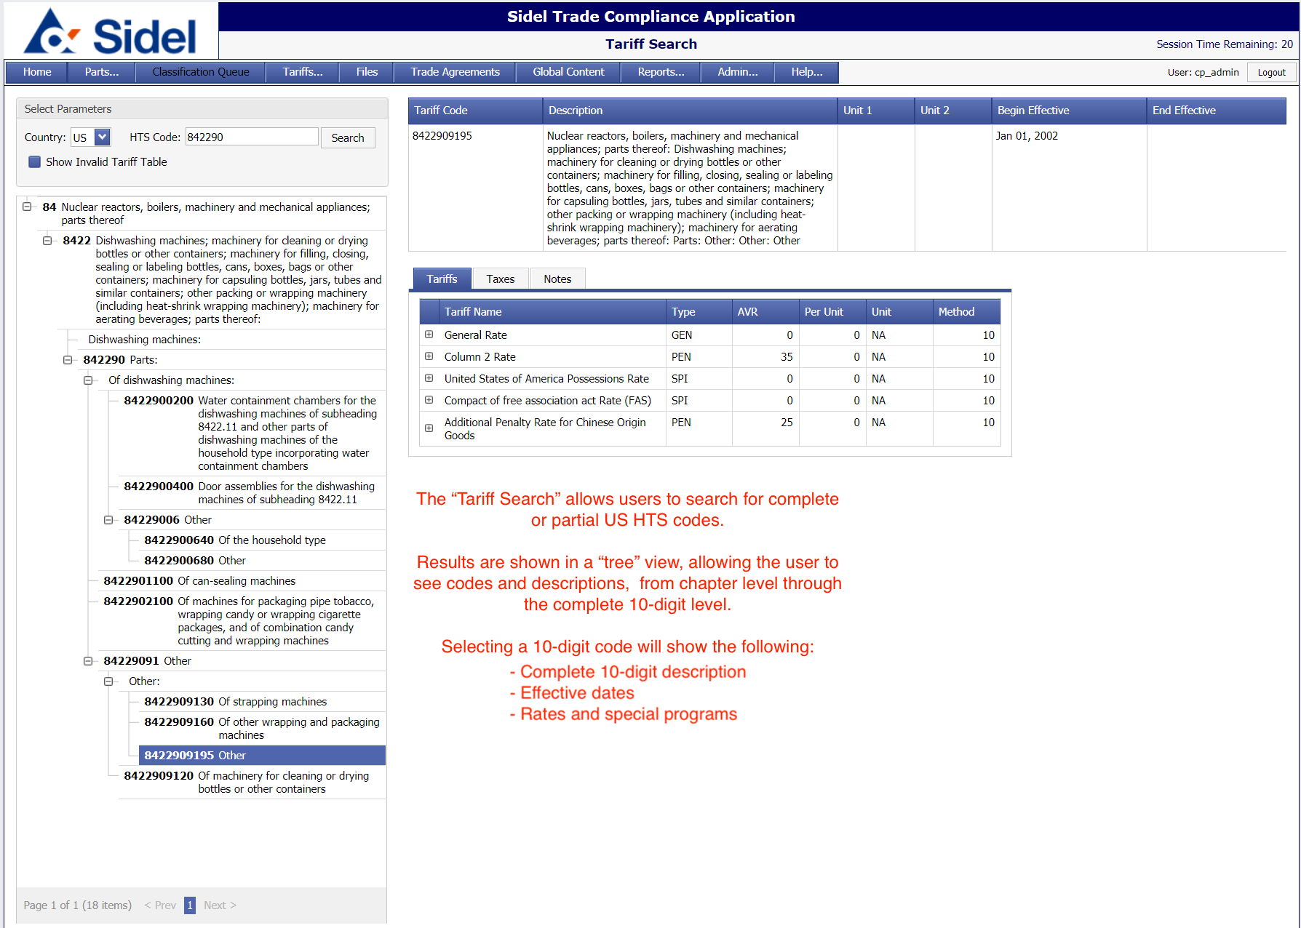
- Support
  - For support issues contact:
    - Patrick Doyle
    - Email: patrickd@customspoint.com
    - Phone: 512.983.0294

